**Report on ISRO START -Space Awareness Program conducted at SCTCE**

Space Science and Technology Awareness Training (START) -2024 was organised by Indian Institute of Remote Sensing (IIRS), ISRO, Dehradun  as an introductory level online training in space science and technology for the under-graduate and post-graduate students. The training programme aimed to attract the youngsters to the fields of space science and technology. The START programme was conducted through ISRO E-CLASS platform [https://eclass.iirs.gov.in](https://eclass.iirs.gov.in/), starting from 24th April to 10th May. Important topics covered include exploration of the solar system, Laboratory Analysis to understand Solar System Conditions, and India’s lunar exploration programme. The schedule of events and details of sessions are given in the schedule attached.

SCTCE was selected as an approved nodal centre for ISRO START on satisfying all the required facilities. A total of 48 students, from final semesters of all branches registered under our nodal centre. Further 55 students also registered in individual mode. Out of the 48 students, 17 students satisfied the 70% attendance eligibility criteria for appearing for the final examination. The final exam was conducted in online mode on 22nd May 2024. Many students have said that the timing of the course just before the commencement of the final project presentations and university examinations made it difficult for them to attend all the sessions. This was the reason for low attendance for many students. This was communicated during the feedback session of ISRO START on 10 th May. Out of the 17 students who appeared for the exam, 16 have passed and were awarded certificate. The response of the students about the content of the programme was good.

The list of students who satisfied attendance eligibility and also passed the final examination is given in Table 1

|  |  |  |  |  |
| --- | --- | --- | --- | --- |
| Sl No | Name | Branch | Grade | Attendance % |
|  | D S Midhun | M8A | A | 81 |
|  | Abhijith V | T8A | B+ | 81 |
|  | Gautham Narayan | M8 | B+ | 70 |
|  | Sivakami R L | M8 | A | 96 |
|  | Anand V | M8 | A | 74 |
|  | Rahul R | M8 | A | 100 |
|  | Sanjay T George | M8 | A | 85 |
|  | Malavika Rajeev | M8 | B | 89 |
|  | S Easwar | M8 | A+ | 100 |
|  | Safeer S S | M8 | B+ | 81 |
|  | Sreeparvathi V A | M8 | B | 78 |
|  | Jishnu S Jayan | M8 | A | 85 |
|  | Suryakiran S | M8 | A | 85 |
|  | Akhil krishnan | M8 | A | 93 |
|  | Atheendran S | M8 | B | 96 |
|  | Sooraj Krishna S | M8 | B+ | 89 |

List of students who satisfied the eligibility criteria for attendance but did not clear the examination

1. Aravind A P M8

List of students who did not satisfy the eligibility criteria for attendance

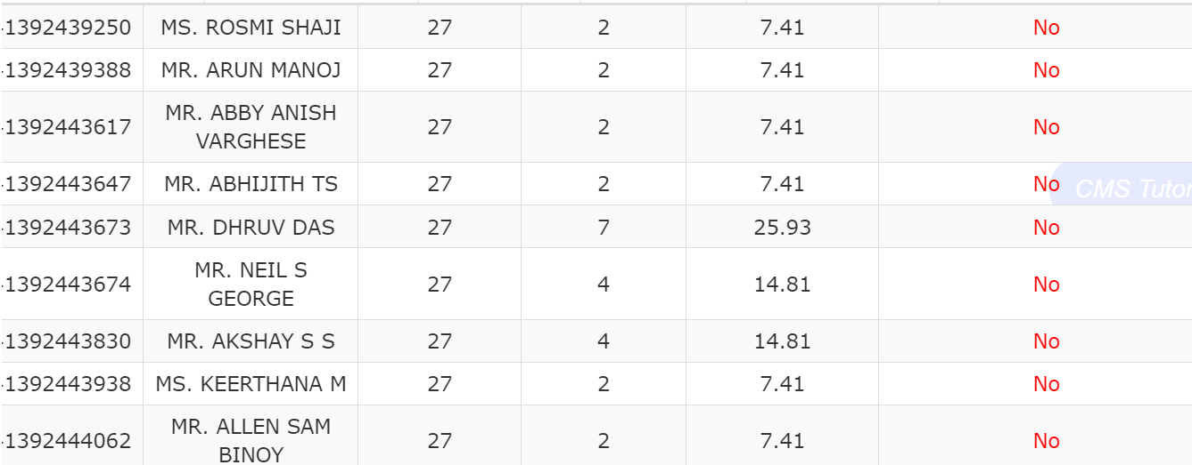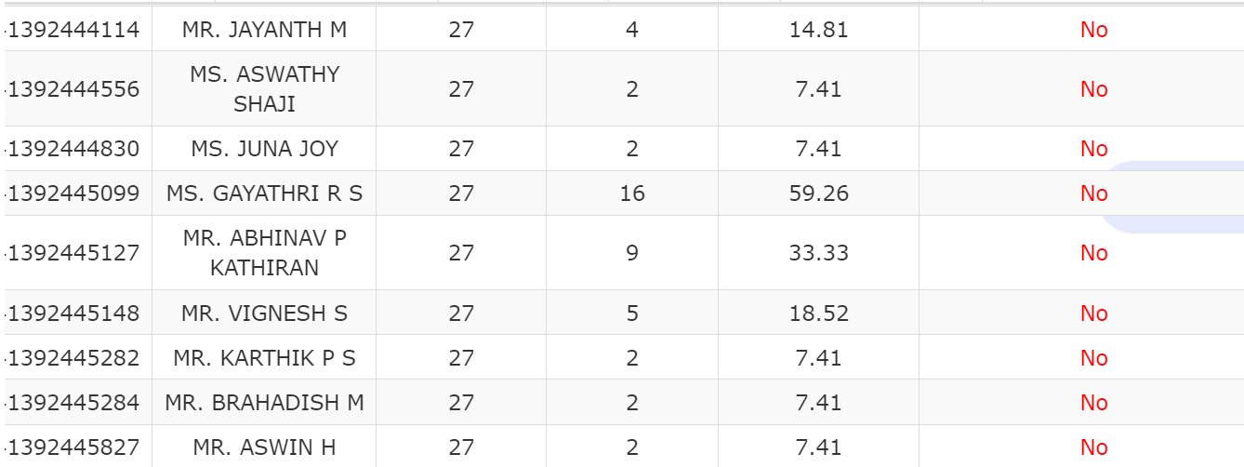

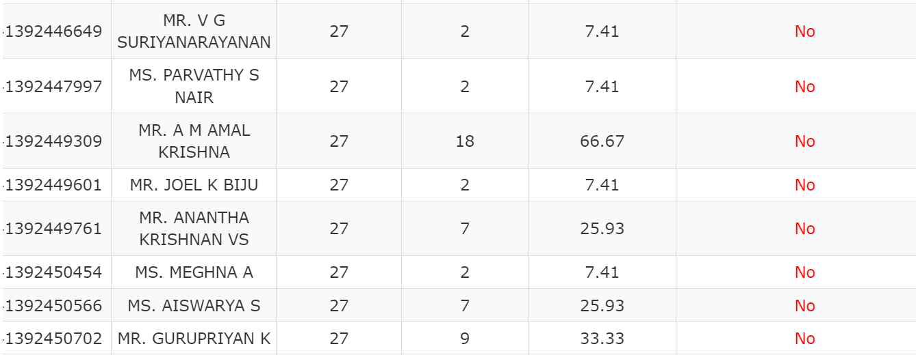

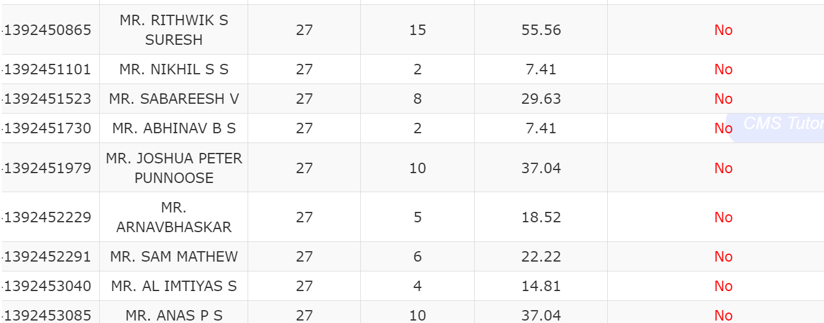

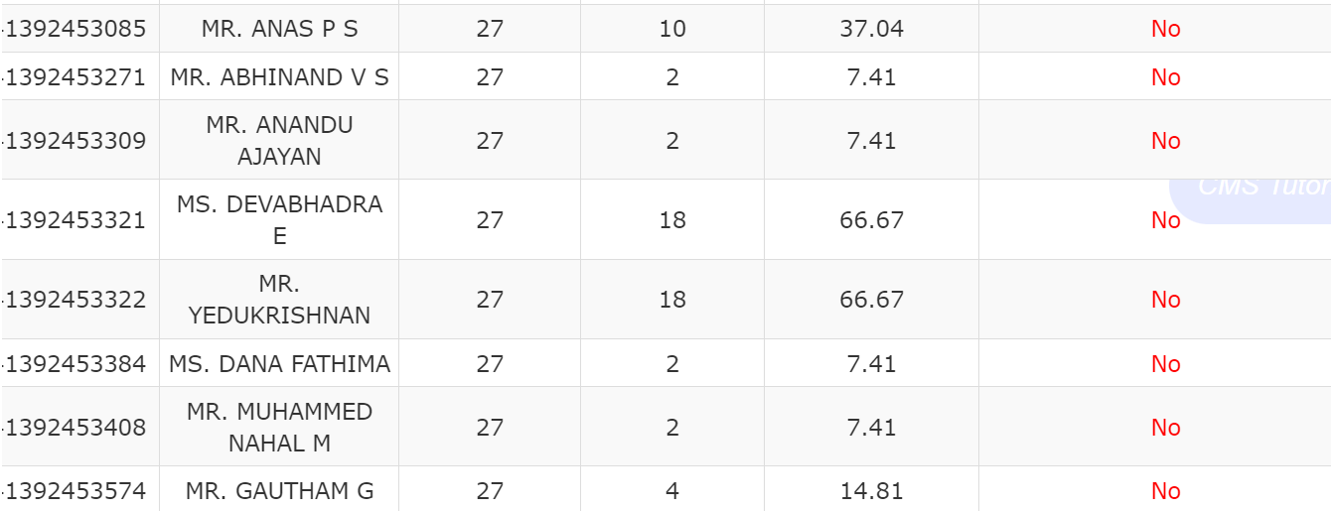

Trivandrum Dr Nisha Jose K

9-6-24 Coordinator

Assoc Professor, Dept of ECE, SCTCE